5. Missionaries and Cannibals Problem

Aim
To implement the Missionaries and Cannibals Problem using Breadth-First Search (BFS).

Algorithm
- Represent the state as (Missionaries Left, Cannibals Left, Boat Side).
- Start with all missionaries and cannibals on the left bank.
- Generate all valid moves.
- Check if the state is safe (missionaries are never outnumbered).
- Mark visited states.
- Repeat until the goal state is reached.
- Display the sequence of states.
Pseudocode
Start
Initialize initial state (3,3,1)
Initialize goal state (0,0,0)

While queue is not empty
Remove current state
If goal reached
Display solution
Stop
Generate valid next states
Add unvisited safe states to queue
End While

Stop
Code:
from collections import deque

moves = [(1,0),(2,0),(0,1),(0,2),(1,1)]

def safe(m, c):
return (m == 0 or m >= c) and (3-m == 0 or 3-m >= 3-c)

def bfs():
queue = deque([(3,3,1)])
visited = set()

while queue:
m, c, b = queue.popleft()

if (m,c,b) in visited:
continue

visited.add((m,c,b))
print((m,c,b))

if (m,c,b) == (0,0,0):
print("Goal Reached")
return

for dm, dc in moves:
if b == 1:
nm, nc, nb = m-dm, c-dc, 0
else:
nm, nc, nb = m+dm, c+dc, 1

if 0 <= nm <= 3 and 0 <= nc <= 3 and safe(nm,nc):
queue.append((nm,nc,nb))

bfs()
Output:
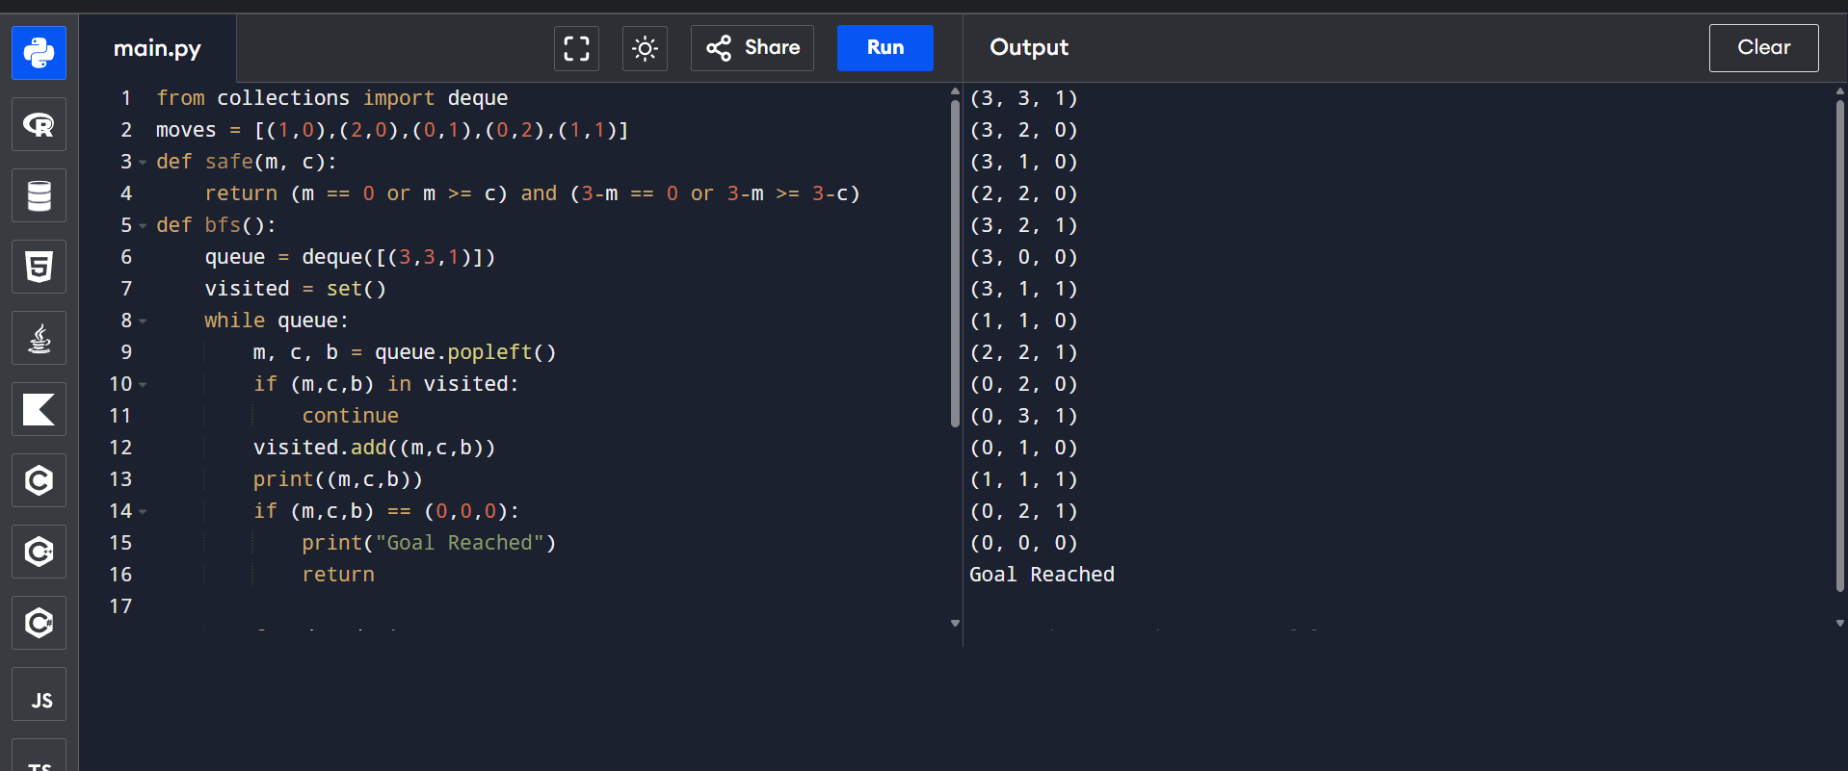

6. Vacuum Cleaner Problem

Aim
To implement the Vacuum Cleaner Problem for cleaning dirty rooms.

Algorithm
- Define two rooms (A and B).
- Check whether each room is dirty.
- If the room is dirty, clean it.
- Move to the next room.
- Repeat until all rooms are clean.
- Display the final status.
Pseudocode:
Start
Initialize Room A and Room B

For each room
If room is dirty
Clean the room
Display final status

Stop

Code:

rooms = {
"A": "Dirty",
"B": "Dirty"
}

for room in rooms:
print(room, ":", rooms[room])

if rooms[room] == "Dirty":
print("Cleaning", room)
rooms[room] = "Clean"

print("\nFinal Status")

for room in rooms:
print(room, ":", rooms[room])

Output:
